~Asia-China-Mirror-Warring States- (475-221 BCE)- Arc 8- Bat 4- Cloud 8

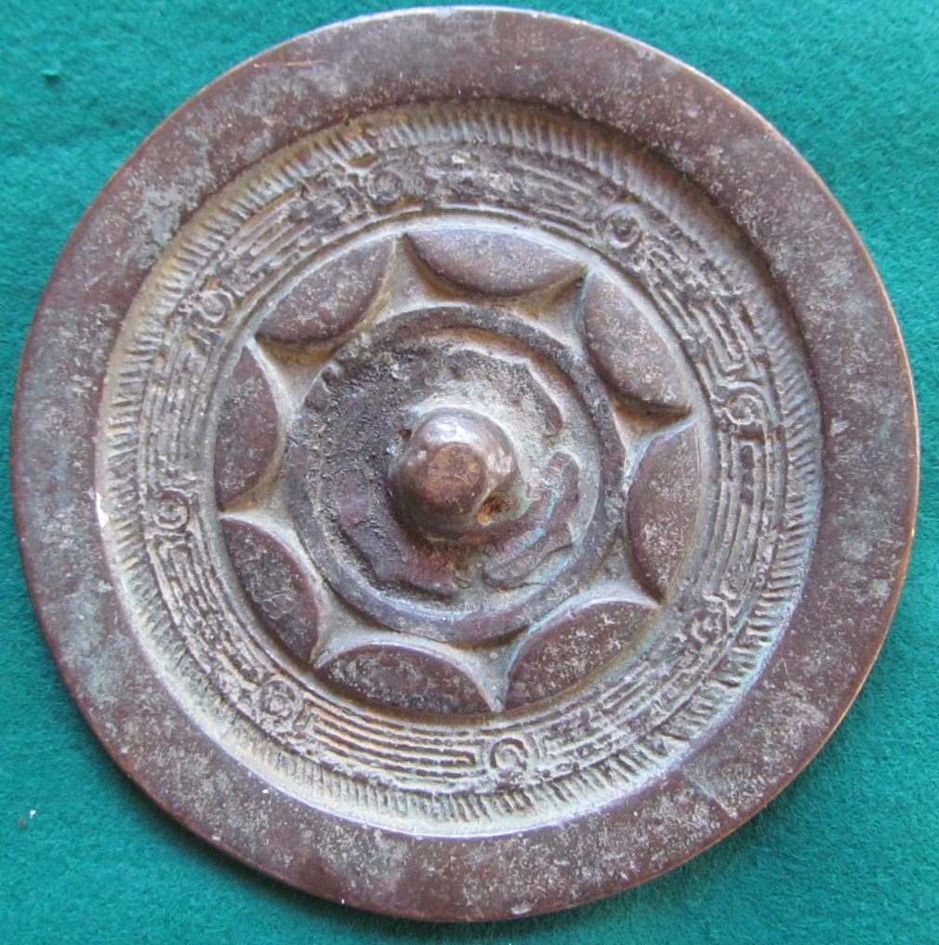

This design features a plain rim, a band of hachuring, an 8 segmented cloud motif with a maze design and 8 continuous arcs and a central plain boss surrounded with 4 bat-like arrows.